|  |  |  |
| --- | --- | --- |
| 0.6M | 1.2M | 1.5M |
| T8B0601 | T8B1201 | T8B1501 |
| 10W | 20W | 25W |

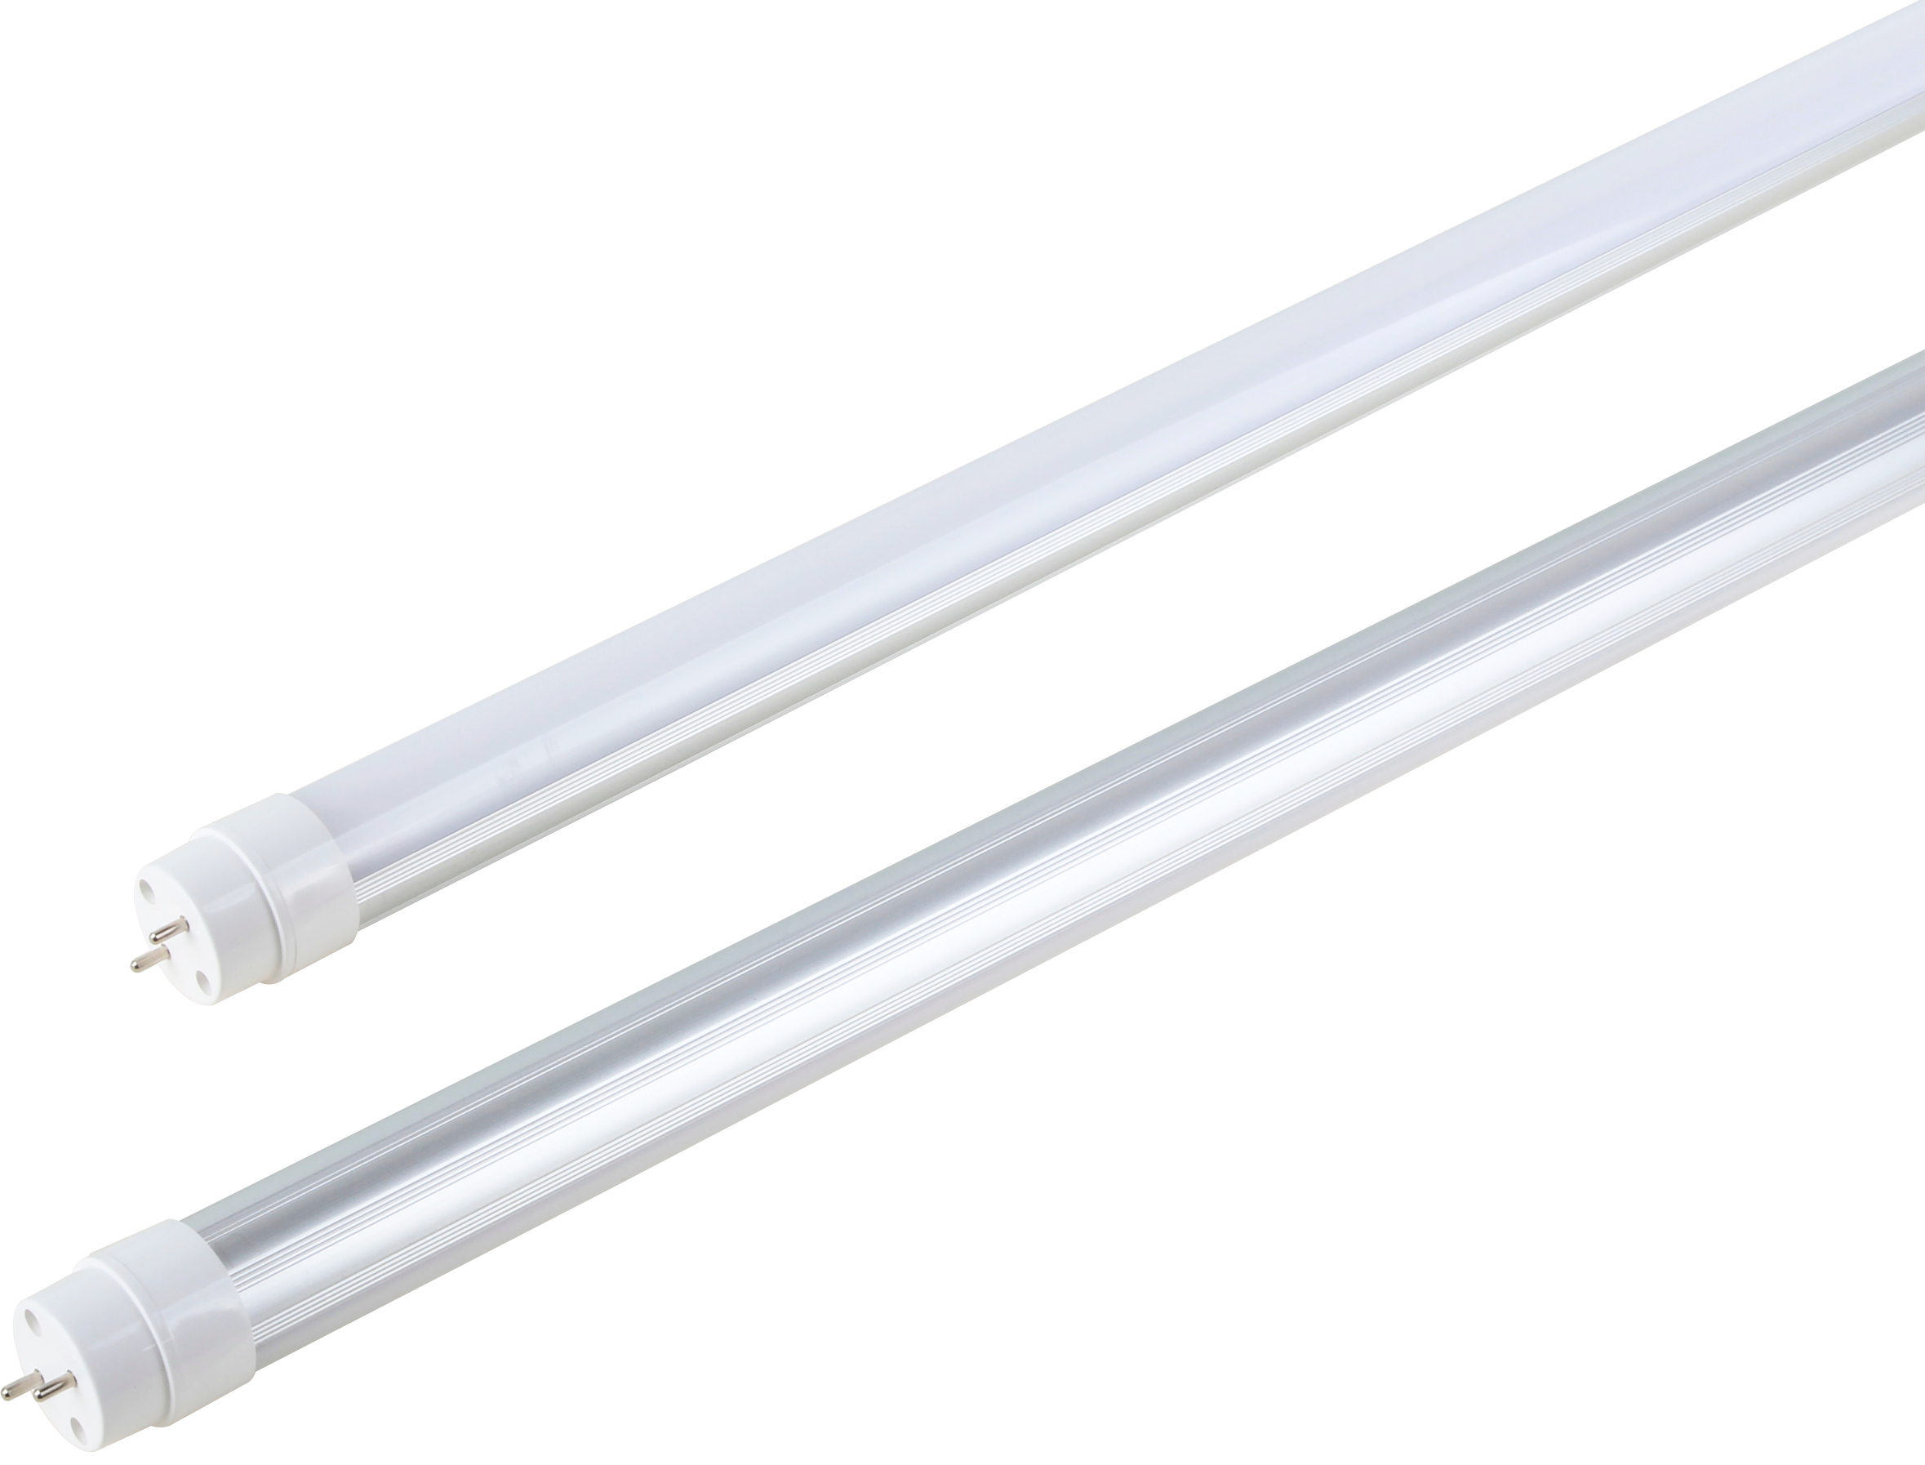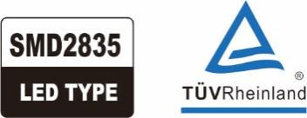Product Appearance Dimensions:

T8 AL+PC rotatable cap tube light specification

LED

|  |  |
| --- | --- |
| T8 Wide Beam Angle Tube | Product Features: |
| C:\Users\Administrator\Desktop\f809017c0e1697fd457c0e5b31e5f8f.pngf809017c0e1697fd457c0e5b31e5f8f | 1.With internal isolated power supply.  2.Use the most mature international well-known LED SMD2835 as the light source, which can ensure the led tube brightness and long lifetime, also can reduce the light decay.  3.Use the high quality aluminum PCB for LED’s better heat dissipation.  4.High-grade PC cover with nice light transmittance (>95%), Transparent PC cover and frosted PC cover are available.  5.120º beam angle makes the lighting effect better.  6.Ambient temperature:-20℃~40℃, surface temperature: 42℃~45℃.  7.No mercury, lead or other hazardous materials; no radiation, no electromagnetic radiation, no frequency flash, instant startup, no hurting eyes. |



|  |  |  |  |  |
| --- | --- | --- | --- | --- |
| **Standard Length** | Dimension(mm) | | | |
| A | B | C | D |
| **0.6M** | **590** | **597** | **604** | Φ**26** |
| **1.2M** | **1199** | **1207** | **1214** | Φ**26** |
| **1.5M** | **1500** | **1507** | **1514** | Φ**26** |

Product Spec.

|  |  |  |  |  |  |  |  |
| --- | --- | --- | --- | --- | --- | --- | --- |
| Model number  型号 | Dimension  尺寸(mm) | CCT  色温 | Power(W)  功率 | Luminous Flum  光通量（lm） | Input Voltage  输入电压 | PF | LED Q,ty  LED数量 |
| T8B0601 | 600*Φ26 | WW:1800K | 10W±8％ | 800lm | AC95-265V | 0.92 | 108pcs |
| T8B1201 | 1200*Φ26 | 20W±8％ | 1500lm | 192pcs |
| T8B1501 | 1500*Φ26 | 25W±8％ | 1900lm | 232pcs |

**以上参数公差范围**±**8%**

Product Structure:



Installation:

***Installation of One Side Power in Tube:***



***Installtion of Both Sides Power in Tube:***

Packing Info:

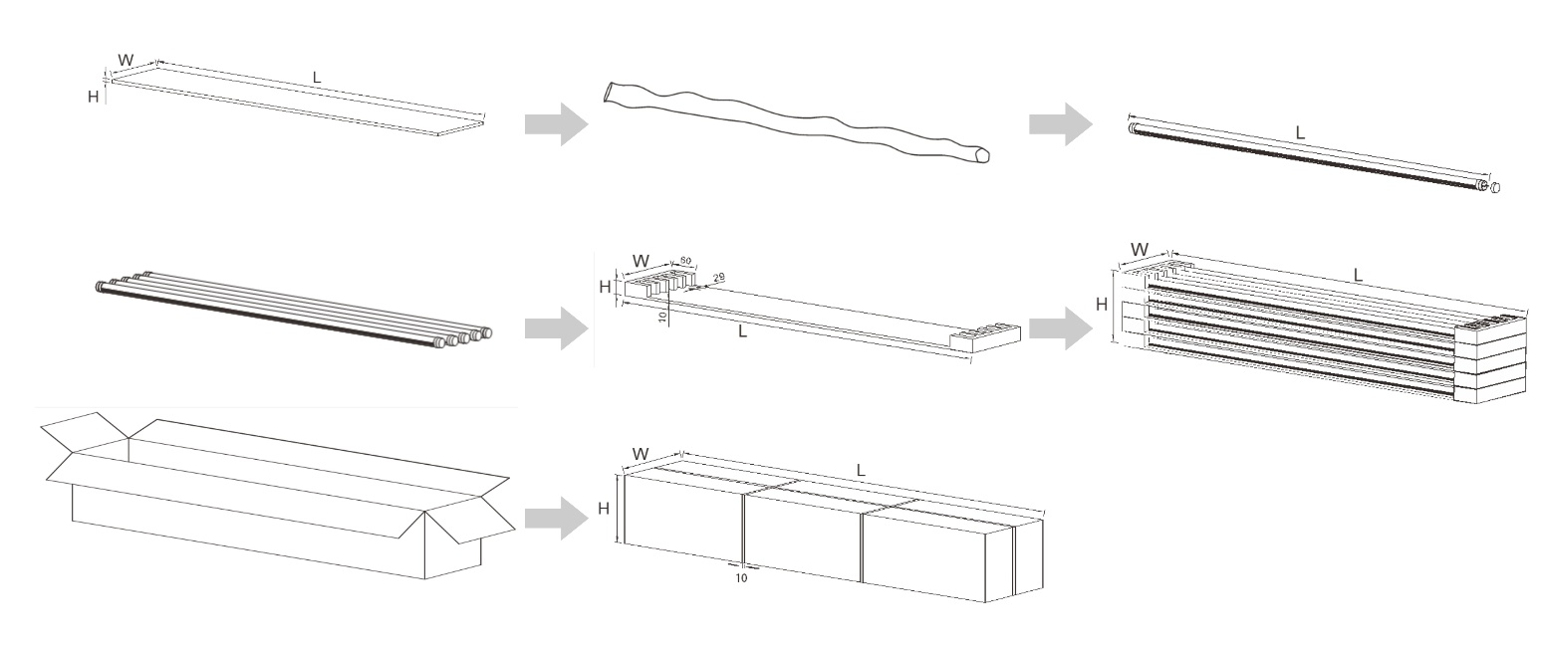

|  |  |  |  |  |
| --- | --- | --- | --- | --- |
| Model | NW/GW （PC） | Carton Size | Q'ty/CTN | GW./ CTN |
| T8B0601 |  | 670*220*220MM | 25PCS/Carton |  |
| T8B1201 |  | 1270*220*220MM | 25PCS/Carton |  |
| T8B1501 |  | 1570*220*220MM | 25PCS/Carton |  |

Application:

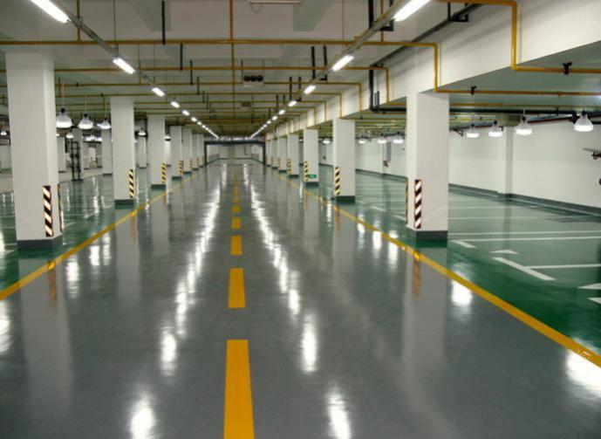 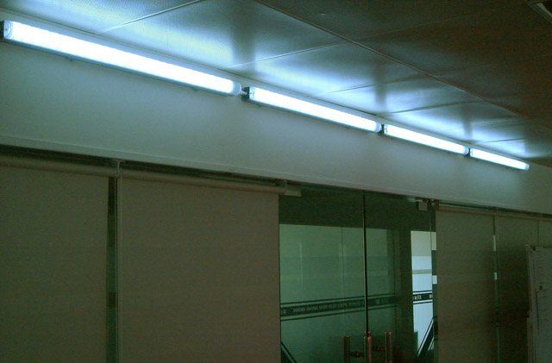

Indoor Lighting / Schools / Universities / Hospital / Conference Rooms / Show Rooms / Factories / Offices / Chain Stores / Supermarkets / Metro Station / Underground Parking.