
LED
T8一体化灯管规格书
T8 Incorporate LED Tube

0.6M | 1.2M | 1.5M
T8-D0620 | T8-D1220 | T8-D1520
10W | 20W | 25W
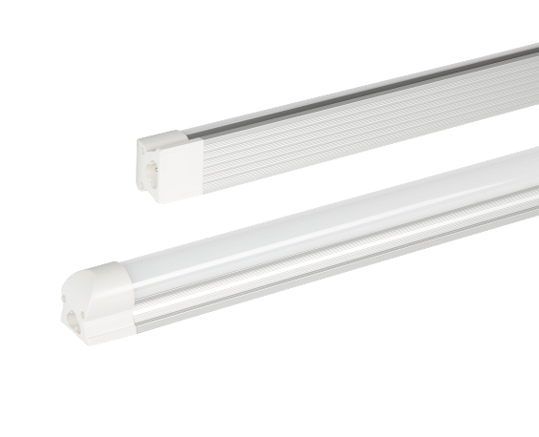

ProductAppearance Dimensions:
T8 Incorporate Tube Datasheet | Product Features:
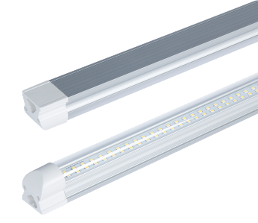 | 1.With internal Non-isolated power supply.  2.Use the most mature international well-known LED SMD2835 as the light source, which can ensure the led tube brightness and long lifetime, also can reduce the light decay.  3.Use the high quality aluminum PCB for LED’s better heat dissipation.  4.High-grade PC cover with nice light transmittance (>95%), Transparent PC cover and frosted PC cover are available.  5.140º beam angle makes the lighting effect better.  6.Ambient temperature:-20℃~40℃, surface temperature: 42℃~45℃.  7.No mercury, lead or other hazardous materials; no radiation, no electromagnetic radiation, no frequency flash, instant startup, no hurting eyes.  8. IP rate: IP 20
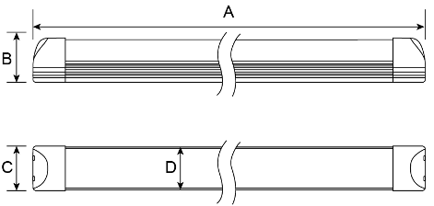
Standard Length | Dimension(mm)
Standard Length | A | B | C | D
0.6M | 600 | 33 | 31 | 28
1.2M | 1200 | 33 | 31 | 28
1.5M | 1500 | 33 | 31 | 28

Product Spec.
Model number  型号 | Dimension  尺寸(mm) | CCT  色温 | Power(W)  功率 | Luminous Flum  光通量（lm） | Input Voltage  输入电压 | PF | LED Q,ty  LED数量
T8-D0620 | 600*28*33 | WW:2500-2800K  2800-3200K  DW:3750-4250K  PW: 4750-5300k  5700-6500k | 10W±8％ | 1300lm | AC95-265V | 0.92 | 120pcs
T8-D1220 | 1200*28*33 |  | 20W±8％ | 2600lm | AC95-265V | 0.92 | 240pcs
T8-D1520 | 1500*28*33 |  | 25W±8％ | 3250lm | AC95-265V | 0.92 | 288pcs

Above test parameter has a tolerance ±8%

Photoelectric Test Report
10W 0.6M
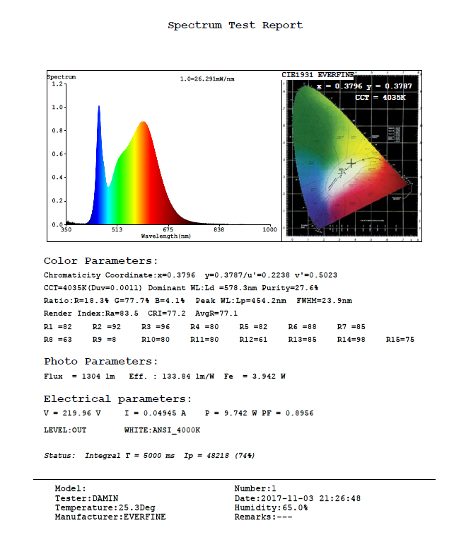
20W 1.2M
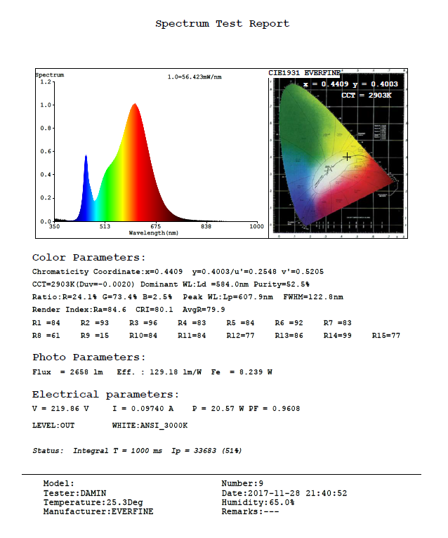
25W 1.5M
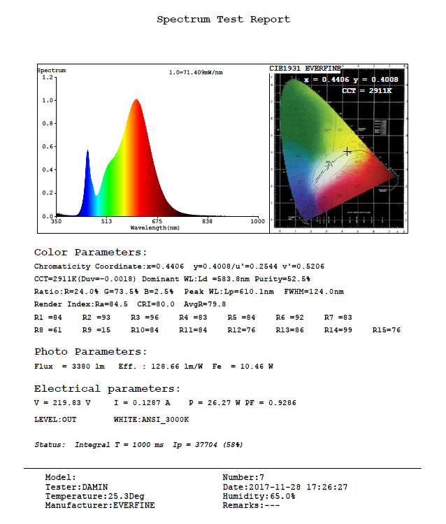

Luminous Intensity Distribution:
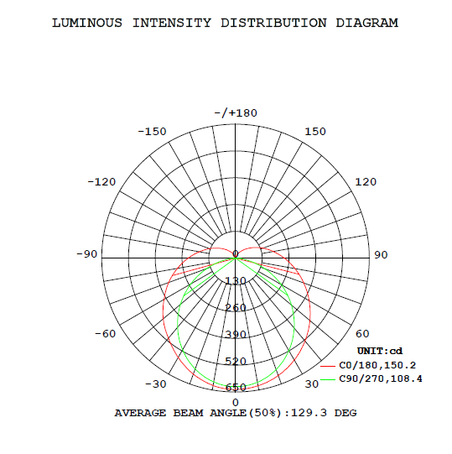
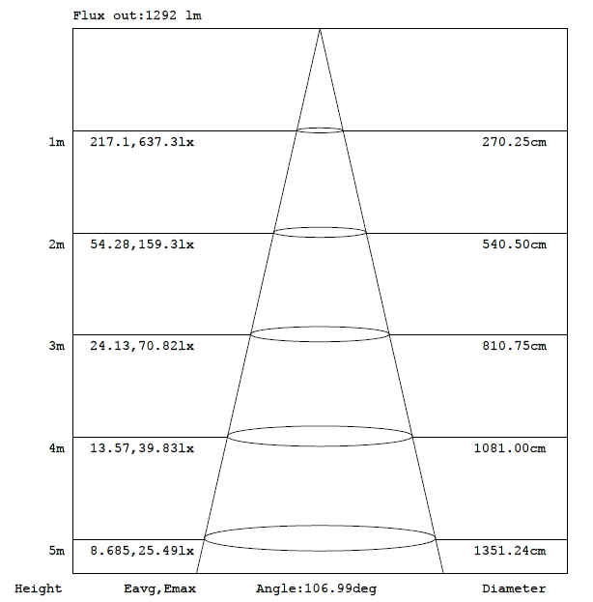
Product Structure:
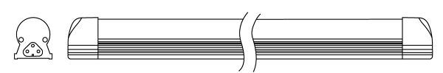
Installation:
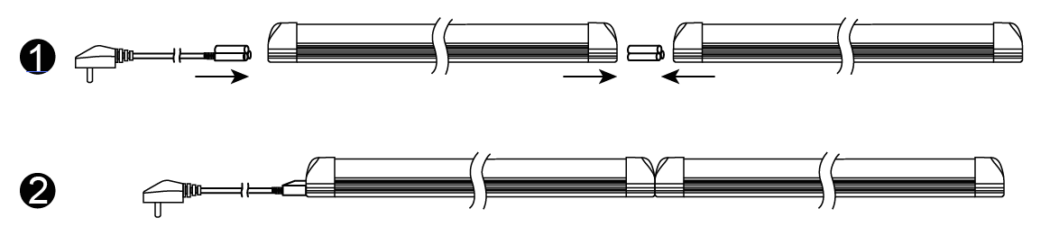

Max.Connection Q’ty:12Pcs for 25W; 15Pcs for 20W; 30Pcs for 10W;(AC220V)

Attention
Please cut off the power before installation.
Please cut off the power if change lamp.
No touching the exposed power connection pins while the lamp is on power

Packing Info:
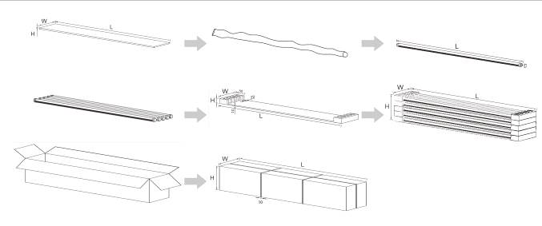
Model | NW/GW （PC） | Carton Size | Q'ty/CTN | GW./ CTN
T8-D0620 | 0.22kg | 670*220*220MM | 25PCS/Carton | 6.5kg
T8-D1220 | 0.41kg | 1270*220*220MM | 25PCS/Carton | 11.8kg
T8-D1520 | 0.51kg | 1570*220*220MM | 25PCS/Carton | 14kg

Application:
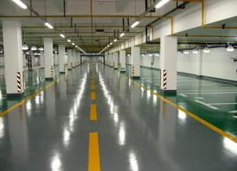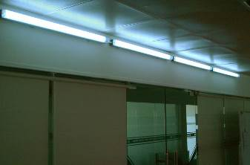
Indoor Lighting / Schools / Universities / Hospital / Conference Rooms / Show Rooms / Factories / Offices / Chain Stores / Supermarkets / Metro Station / Underground Parking.

