TNT IP20 Indoor Logo Projector Technical Parameters
Model： | TNT-QR-16
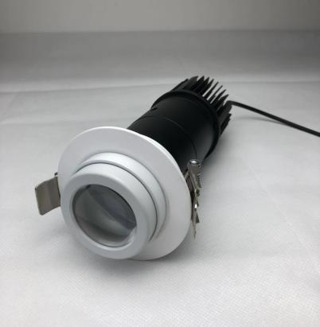 | Wattage：16W  Luminous Flux:2000LM  Gross Weight:1.5kg  Inner package size:32*16*14cm  Outer package size:61*51*41cm  Quantity of outer box:12pcs
Input Voltage:110V-240V Power adapter /Working Frequency:50-60Hz
Light Source Type：Big Power LED Lamp Bead
Adaptor:Meanwell APC-16-350
Color Temperature:7000K
Life Span:40000h
Lamp Color:Black
Shell Material: High-quality Aluminum
Surface Treatment:Oxidation
Cooling Method:High efficient Cold forging heat dissipation
Waterproof degree: IP20 indoor use only
Light Spot Diameter:Project Distance multiply by 0.35
Install Method:Embedded in ceiling
Rifice diameter:75mm

Model： | TNT-GD-20
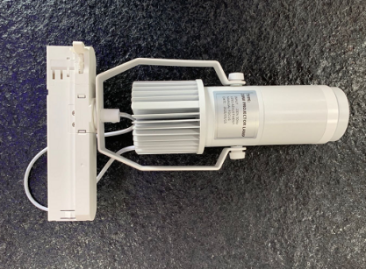 | Wattage：20W  Luminous Flux:2400LM  Gross Weight:1.5kg  Inner package size:39*24*14cm  Outer package size:61*51*41cm  Quantity of outer box:8pcs
Input Voltage:100V-240V
Power adapter /Working Frequency:50-60Hz
Light Source Type：Big Power LED Lamp Bead
Adaptor:Power gear 4cores track
Color Temperature:7000K
Life Span:40000h / Projection Angle：360°
Lamp Color:Black/white optional
Shell Material: High-quality Aluminum
Surface Treatment:Oxidation
Cooling Method:High efficient Cold forging heat dissipation
Waterproof degree: IP20
Light Spot Diameter:Project Distance multiply by 0.35
Install Method:install in 4cores rail

Model： | TNT-SN-30R
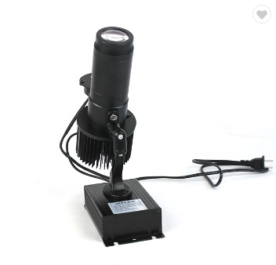 | Power：30W  Luminous Flux:3600LM  Gross Weight:2kg  Inner package size:39*24*14cm  Outer package size:61*51*41cm  Quantity of outer box:8pcs
Input Voltage:200V-240V
Power adapter /Working Frequency:50-60Hz
Light Source Type：Big Power LED Lamp Bead
Color Temperature:7000K
Adaptor：Meanwell APC35-700
Life Span:40000h / Projection Angle：1080°
Lamp Color:Black
Shell Material: High-quality Aluminum
Surface Treatment:Oxidation
Cooling Method:High efficient Cold forging heat dissipation
Waterproof degree: IP20
Light Spot Diameter:Project Distance multiply by 0.35
Install Method:Surface mounted

